**Battle of the Dublin Districts**

Yash Karle

**1. Introduction**

**1.1 Background**

* Housing crisis in Dublin  
    
  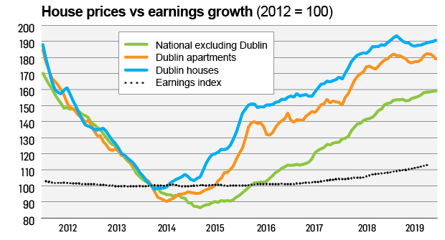

Figure 1: Dublin House Prices [1]

As you can see in the figure house prices in Dublin have risen by almost 90 percent, while wages have increased by only 18 percent since 2012. This is an ongoing social and economic problem in Ireland that the Irish government is trying to solve. Ireland needs an estimated 30,000 new units built annually and it’s been lagging on that front by quite some margin in the last few years. This has led to multiple problems forefront of which are high levels of homelessness, longer commute times and greater wage pressures to meet the costs of living in Dublin. Families, renters, first time buyers and the elderly all have different housing needs as well as drastically different demands from the surrounding neighbourhood. Thereby, mixed housing is the need of the hour to support these varied range of demographically distinct population clusters.

* 15-minute city – impact of Covid-19  
    
  Given this context in terms of a national housing crisis (effect magnified in the capital which has majority of the urban population) arrives a global pandemic – Covid-19. Dublin City Council have accelerated their urban development plans along with the “Dublin Chamber” [2] initiative which tries to mimic 15-minute city initiative pilots in cities across the globe including Paris, Barcelona, Melbourne and London. As part of this and as the name suggests emphasis will be given on the needs of the ever-increasing urban density, enhanced public transport and investment in public realm. They are essentially proposing better livability and walkability of urban neighbourhoods to ensure more sustainable communities. Especially in the post-Covid world with the changing ways of working it is a great time to kickstart reimagining of neighbourhoods.

**1.2 Problem**

* The perfect neighbourhood - 5K lockdowns
* Skewed distribution of amenities and opportunities

**1.3 Interest**

* Find the right house for me!
* Grow Remote
* Hyper-personalisation

**2. Data acquisition and cleaning**

**2.1 Data sources**

* Daft-scraper API
* Foursquare API

**2.2 Data cleaning**

* Feature Extraction
  + Neighbourhood
  + SellerId
  + FloorArea
  + Longitude
  + Latitude
  + BerRating
* Missing data
  + Price
  + NumBedrooms
  + NumBathrooms
  + BerRating

**2.3 Feature selection**

* Feature Synthesis
  + PricePerBedroom
  + DeltaAvgPrice
  + DeltaMedianPrice
  + NorthSouthFlag
  + DistanceToCity
  + DaysSincePublished
  + NumFood
  + NumRecreation
  + NumShop
* Aggressive filtering
  + Zero Price
  + Null values for newly added features

**3. Exploratory Data Analysis**

**3.1 Relationship between Price and SellerId**

**3.2 Relationship between Price and NumBedrooms**

**3.3 Relationship between Price and FloorArea**

**3.4 Relationship between Price and DistanceToCity**

**3.5 Relationship between Price and NumFood**

**3.6 Relationship between Price and NumRecreation**

**3.7 Relationship between Price and NumShop**

**4 Clustering**

**4.1 DBSCAN clustering**

* Property characteristics

[NumBedrooms, NumBathrooms, FloorArea]

* Location characteristics

[Longitude, Latitude]

* Neighbourhood characteristics

[NumFood, NumRecreation, NumShop]

**4.2 Solution to the problem**

* New Localism
* Is the house price justified?
  + for its characteristics
  + and that of its neighbourhood?
* Ranking neighbourhoods
  + for suitability to buy
  + opportunities for small businesses to flourish

**5. Conclusion**

**6. Future directions**

* Fetch seller names from seller id and see if the data makes sense
* Cluster members investigate in more depth
* Most common & least common venues for each neighbourhood
* Removing outliers for price and then redo deciles
* Popular transport routes
* Schools in the neighbourhood influencing house prices?
* Crime rates in a neighbourhood

**References:**

1. Irish Time Article: <https://www.irishtimes.com/life-and-style/homes-and-property/ireland-s-housing-crisis-in-five-revealing-graphs-1.4150332>
2. Dublin Chamber of Commerce Blueprint Document: <https://www.dublinchamber.ie/DublinChamberofCommerce/media/banners/Dublin_The-15-Minute-City.pdf>